50projects in html css and javascript

1. expanding cards
Main idea is to select the panel and give them active class. But if we add active class it remain on all images as shown in the figure given below.
We will use querySelectAll which give us nodelist which is similar to array.

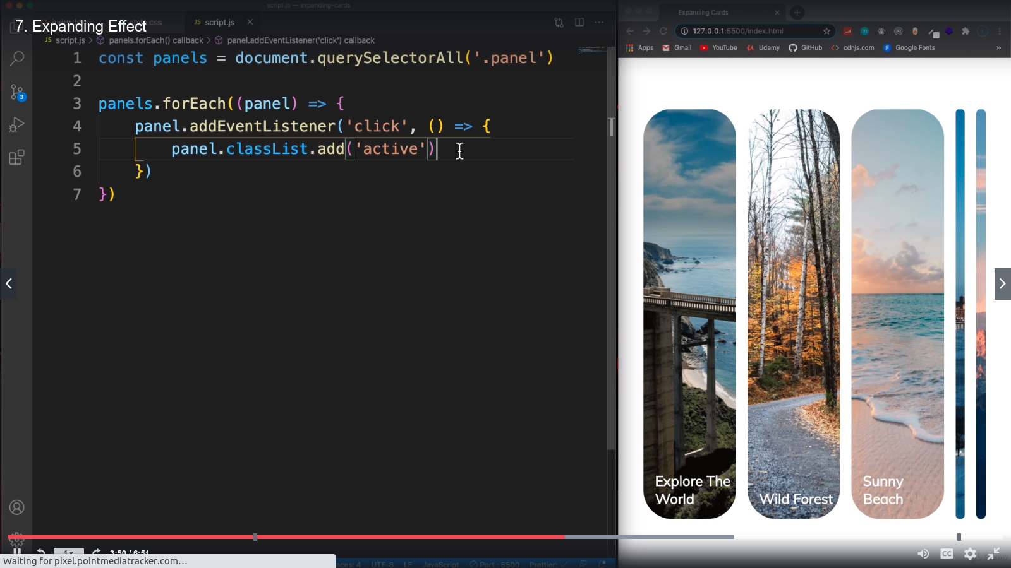

2. Progress Steps(???)
in this project if we click on next it will continue incrementing the value as shown in the figure.

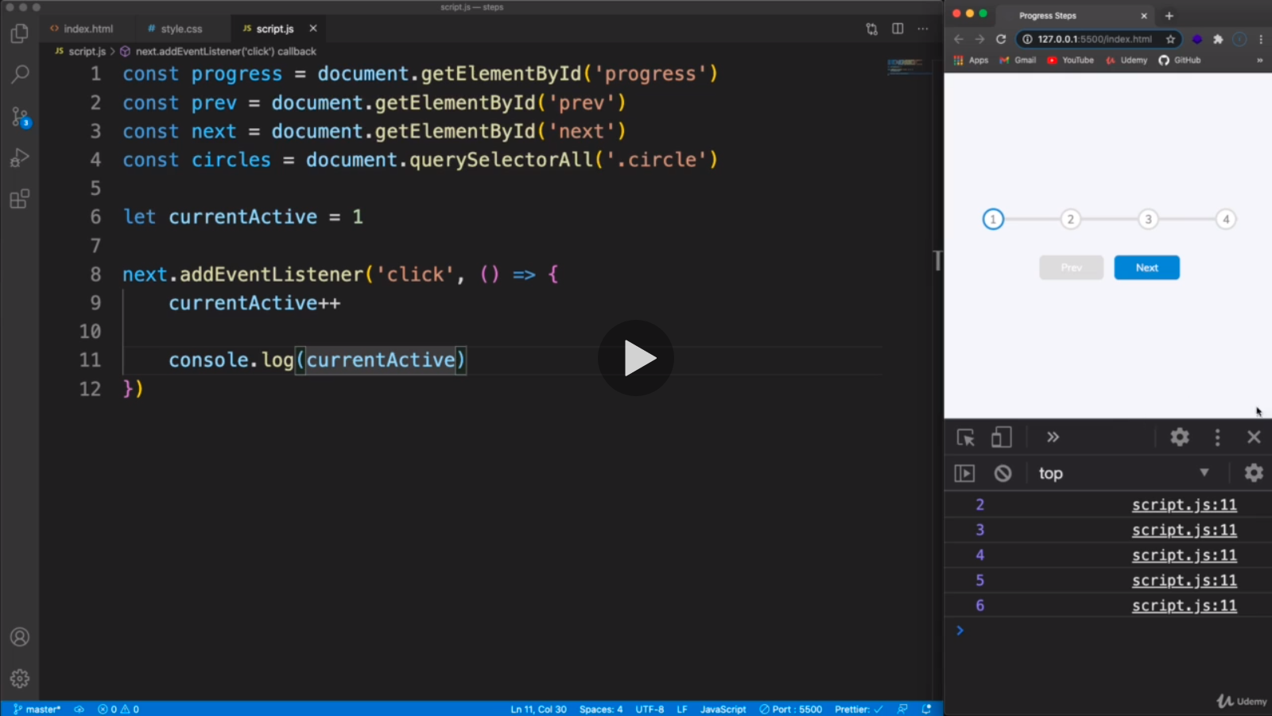
Now will add if statement to limit to its length
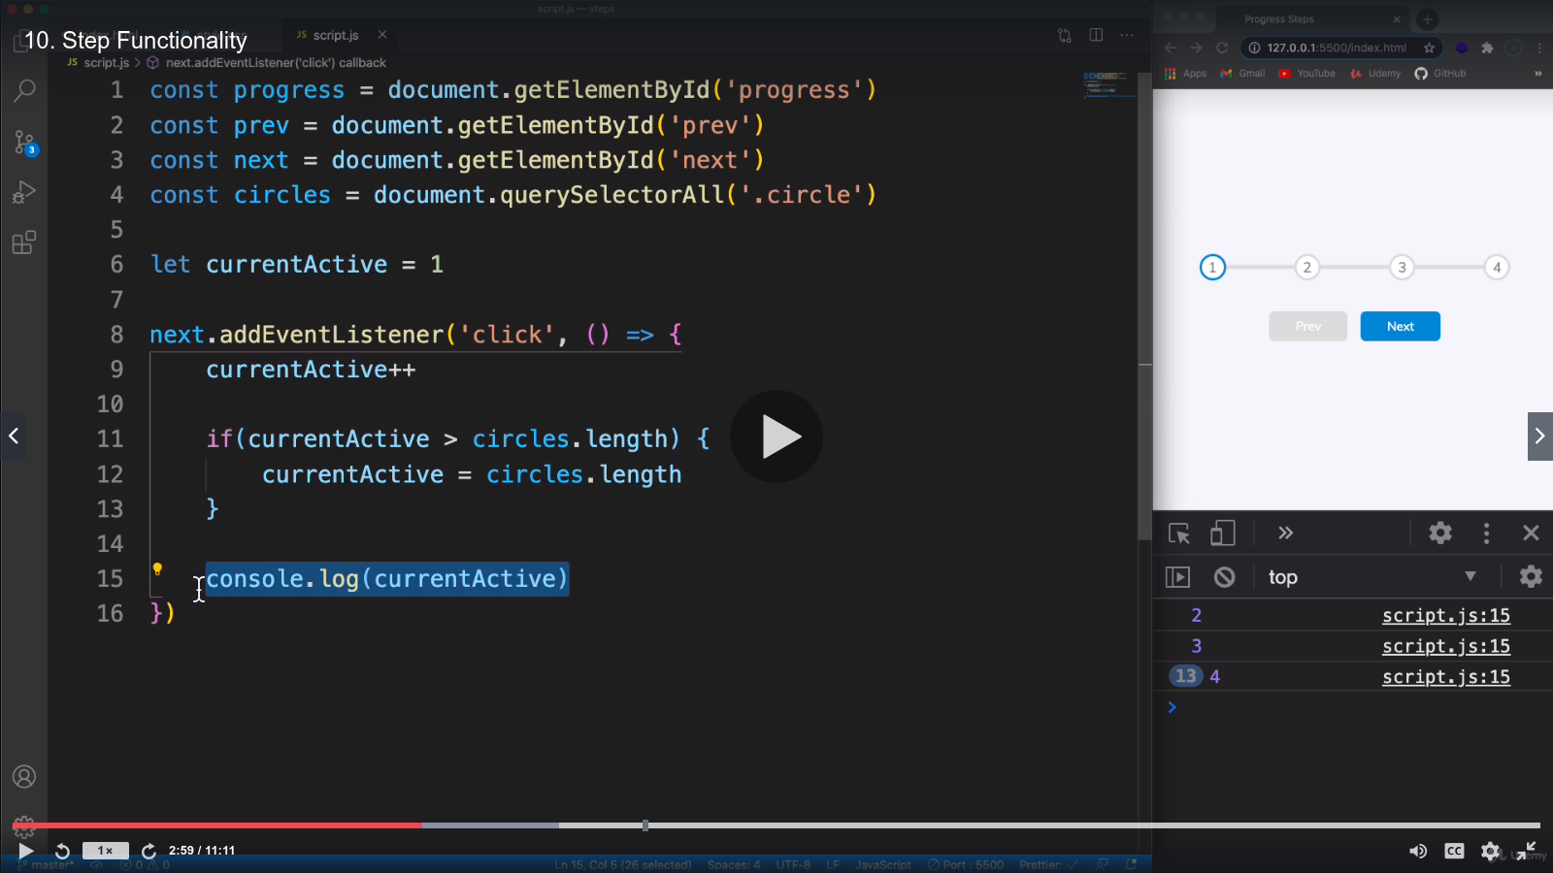
then we will do similar changes for prev button and writing an update function after writing prev.addEventListner. The update function will highlight the circles

